**Tableau UFO Sightings North America**

Instructions: Just like you did in the Tableau Lab example this week, connect to the Citrix Server at Regis University to access the Tableau application.

**Tableau**

You may want to spend a little time visiting the Tableau site to gain some additional information about Tableau as well as watching some of the example videos. You can access Tableau by going to the following URL.

<https://www.tableau.com/>

The training videos are accessible through the following link.

<https://www.tableau.com/learn/training>

Why are we learning Tableau? Tableau is a great visualization tool used in many businesses world-wide. A lot of companies use it with flat files, like Excel spreadsheets to display data. But a good many company’s use Tableau with databases to visually display changing data. Typically, data changes every day, but in some cases, it could be as much as every minute, and so a connection to a database is necessary. We’ll get into connecting to a database later, but for now we need to learn a little bit about Tableau.

**Tableau:**

Once you have successfully gained access to the Citrix Lab select the Tableau application from the list of applications, then connect to Oracle as you did in the Tableau Lab example.

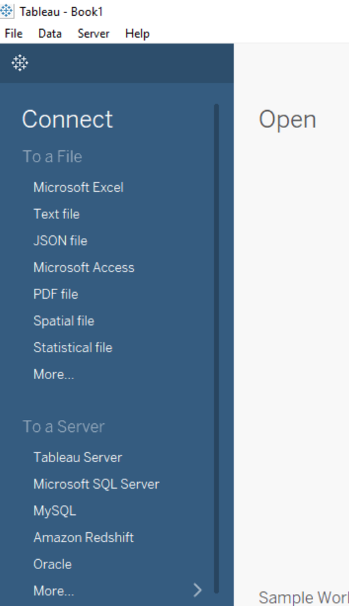



After you connect to Oracle (see instructions in the Tableau Lab example) you will now see an additional table called UFO_NA_Sightings (NA stands for North American).

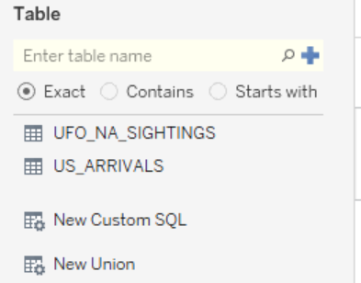

Double click this table and once again click on update now. You know from the lab example that you have to move to sheet1 to start your work.

You’re now on your own to answer these questions (20pts each).

**Exercise #1**

Using a highlight table, what were the top 5 states (with the most reported sightings)?

Name the states (two letter abbreviation) and show your work with a screen shot here:

HINT: Don’t forget to sort the data. Note: Because some sightings didn’t record the state, there are quite a number of Null values, IGNORE those.

**CA, FL, WA, TX, NY (in order from most sightings to least)**

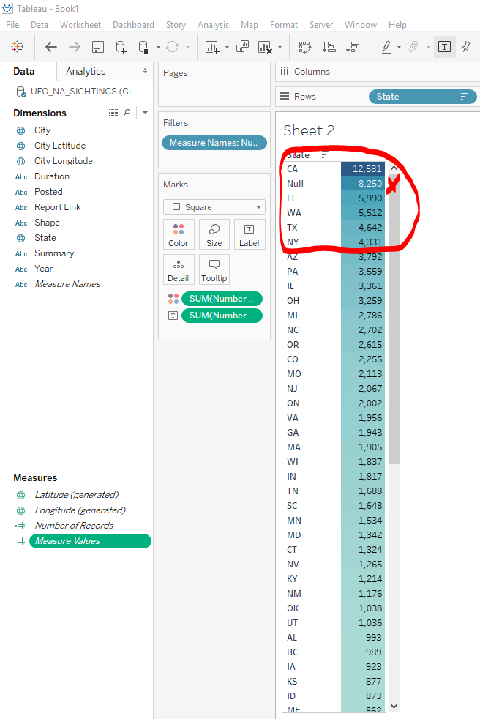

**Exercise #2**

With the same data, show all the states on a map, INCLUDING the number of records in each state.

1. Place your screen shot here (20 pts)

Screen shot

**\*\*\* note that, depending on how ‘zoomed in’ the screenshot was, certain states could not be simultaneously displayed\*\*\***

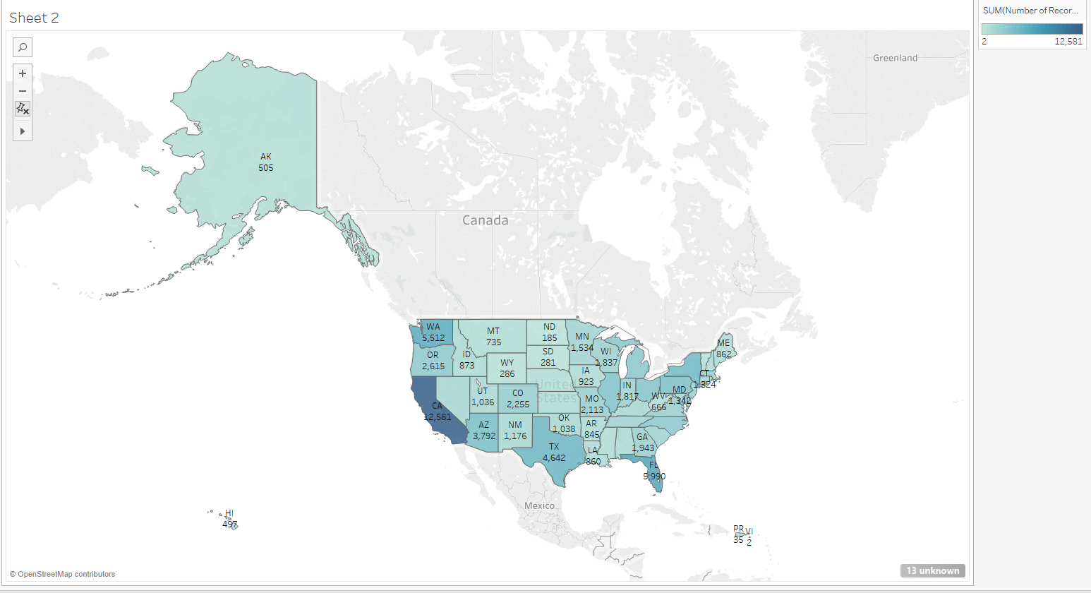

**Exercise #3**

Using a treemap, how many sightings were in Boulder CO? (20pts)

HINT: Filter State to show only Colorado.

HINT2: drag number of records into Label to show the amounts for each city. Don’t forget to add in city. You need to figure out where it goes.

Place your ANSWER and screen shot here.

**Boulder, CO = 93 sightings**

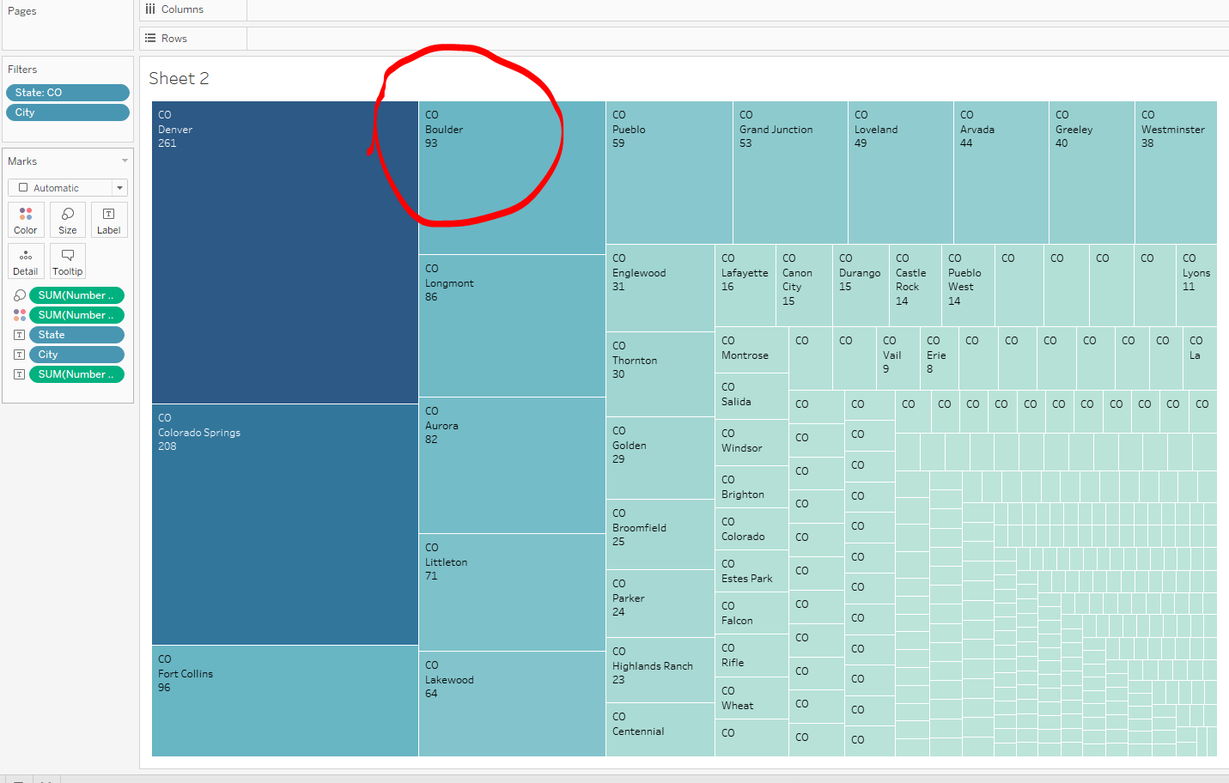

**Exercise #4** (20pts)

Using a packed bubble chart, display in color and with labels the various shapes that were reported all over the country.

HINT: drag shape to Color to display the various colors, number of records to Label to see amounts (smaller numbers will not display.

What was the shape with the largest number? What was the number?

Place a screen shot here.

**Shape with the largest number was “Light = 21,000”.**

**Note: The shape (that was actually a shape) with the largest number was “Circle = 10,343”**

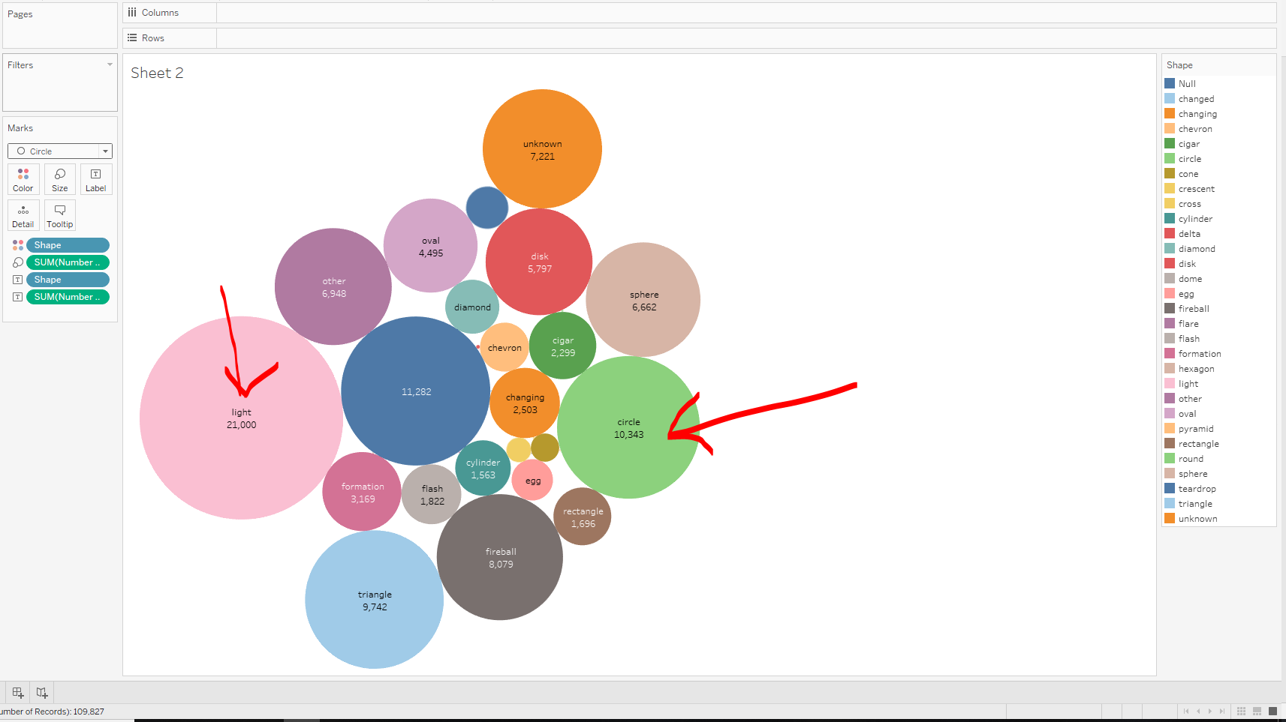

**Exercise #5** (20pts)

Again, using a packed bubble chart, display in color and with labels the years that were reported all over the country.

What year had the greatest number of sightings? What was the amount?

**Year with the largest number was “2014 = 8,321”.**

